- Do not edit/delete any heading or section with red text.
- Type /paste you answers in relevant sections (below Final Answer (in all questions , Approach (wherever required ) and Charts & tables (wherever required)) of the solution
- Link to submission guidelines
- Please note that submission not following the guidelines will not be accepted

OBJECTIVE QUESTIONS

Question 1: What is the total no. of tables present in the data?

Solution:

Final Answer (if any):
2
Approach (if any):
Counted the total number of sheet tabs present in the google sheets containing the raw data.

Charts & Tables (if any):
N/A

Question 2: What is the total no. of attributes present in the data?

Solution:

Final Answer (if any):
22

Approach (if any):
Counted the total number of columns present in the raw Data sheet and country description

Charts & Tables (if any):
N/a

Question 3: How many categorical columns are there in the data? [Search about categorical and continuous data, and try to answer this question]

Solution:

Final Answer (if any):
There are 16categorical columns.

Approach (if any):
Categorical columns are columns that contain non-numeric values while Continuous columns contain numeric data.

Charts & Tables (if any):
N/A

Question 4: The data consists of some inconsistent and missing values so ensure that the data used for further analysis is cleaned.

Solution:

Final Answer (if any):
The data was cleaned by removing inconsistent and missing values to ensure accuracy for further analysis.
Approach (if any):
Check each column manually for missing values,null values ,duplicate rows and blank columns used Excel/google sheet functions like filters,countblank,trim,standardized format for the data .

Charts & Tables (if any):
Sheet name- cleaned data sheet
Description:Contains the finalized dataset after removing blank columns , used for all further analysis.

Question 5: Using the LookUp functions, fill up the countries in the original data using the country code.

Solution:

Final Answer (if any):
Successfully filled the country Name using vlookup based on Countrycode.

Approach (if any):
Using Vlookup function to match to the country code from the cleaned data sheet with the corresponding country name from the country description.
Charts & Tables (if any):
Cleaned Data Sheet(country name column)
Description:using the vlookup function from the country code.

Question 6: Create a table to represent the number of restaurants opened in each country.

Solution:

Final Answer (if any):
A table was created showing the number of restaurants opened in each country.
Approach (if any):
Created a pivot table with country name in rows and count of restaurantID in values,using COUNTA to get the total number of restaurants per country.

Charts & Tables (if any):
COUNTA of restaurantName VS Country Name
Description: Displays the total number of restaurants opened in each country.

Question 7: Also, the management wants to look at the number of restaurants opened each year, so provide them with something here.

Solution:

Final Answer (if any):
A line chart was created showing the number of restaurants opened each year.

Approach (if any):
Created a pivot table with year in rows and Count of RestaurantID in values,than visualized it using Line Chart.

Charts & Tables (if any):
Restaurant Opening by year.
Description:Shows the Yearly trend of restaurant opening from the dataset.

Question 8: What is the total number of restaurants in India in the price range of 4?

Solution:

Final Answer (if any):
COUNTIFS(‘Cleaned Data’! V:V,”INDIA”,’Cleaned Data’!P:P,4)
Approach (if any):
Used COUNTIFS Function to count the total number of Restaurants in INdia in the price range of 4.

Charts & Tables (if any):
N/A

Question 9: What is the average number of voters for the restaurants in each country according to the data?

Solution:

Final Answer (if any):
The average number of votes for restaurants in each country was calculated.India-137.21,Indonesia-772.10,Brazil-19.62,Canada-103,qatar-163.8,Singapore-31.9,Sri Lanka-146.45,United Kingdom-205.49,US-428.22,so overall grand average all countries-156.91.
Approach (if any):
Created pivot table with country name in rows and average of votes in values.

Charts & Tables (if any):
Average of votes by country name
Description: Shows the average number of votes for restaurants in each country.

Question 10: Calculate the average rating for all the restaurants that have price_range < 4 and provide online delivery. Use only the “IF” function, Logical Operators, and Aggregation functions to solve this problem. [Note: Don’t use Conditional aggregation in this question.]

Solution:

Final Answer (if any):
3.27 (approximately)

Approach (if any):
Used an ARRAYFORMULA with IF,Logical operators(<,=),and SUM/ARRAYFORMULA to calculate average rating for restaurants with price-range<4 and Has-Online-delivery=”yes”,without using conditionalaggregation functionlike AVERAGIF.

Charts & Tables (if any):
N/A

Question 11: Using Conditional formatting highlight the rows of restaurants that are located in the countries or cities that you’ve suggested to the management for opening new restaurants.

Solution:

Final Answer (if any):
Applied conditional formatting to highlight rows of restaurants located in Canada,Qatar,Singapore and Sri Lanka in the Cleaned Data Sheet.

Approach (if any):
Selected the entire data range,then used Format>Conditional formatting>Custom formula.

Charts & Tables (if any):
Cleaned data sheet
Description: Rows of Restaurants from suggested countries are visually highlighted for quick identification.

Question 12: Create a new customized price column that consists of the abbreviation/symbol of the currency along with the Average_cost_for_two value. [Use string operations to do this task]

Solution:

Final Answer (if any):
Created a new column “Average_cost_for_two with currency symbol” showing combined values(e,g.,”300 Rs.”).
Approach (if any):
Using formula CONCATENATE.

Charts & Tables (if any):
Cleaned data sheet(Average_cost_for_two with symbolcolumn)
Description:Displays average cost combined the currency symbol for each restaurant.

Question 13: How can you create an array formula in Excel or Google Sheets to count the number of restaurants listed that do not offer online delivery, are in the lowest price range, and have an average cost for two people less than or equal to 250 Indian Rupees?

Solution:

Final Answer (if any):
1834
Approach (if any):
Used an ARRAYFORMULA with SUM
=ARRAYFORMULA(SUM((M2:M10000=”No”)(P2:P1165=1)*(R2:R1165<=250)))
Charts & Tables (if any):
N/A

SUBJECTIVE QUESTIONS

Question 1: Suggest a few countries where the team can open newer restaurants with lesser competition. Which visualization/technique will you use here to justify the suggestions?

Solution:

Approach:
A column chart was created to compare the number of restaurants listed across different countries using COUNTA of restaurantName vs Name ,in order to identify markets with competition.
Charts & Tables:
COUNTA of restaurantsName vs Country Name
Description: Displays the total number of restaurants listed per country.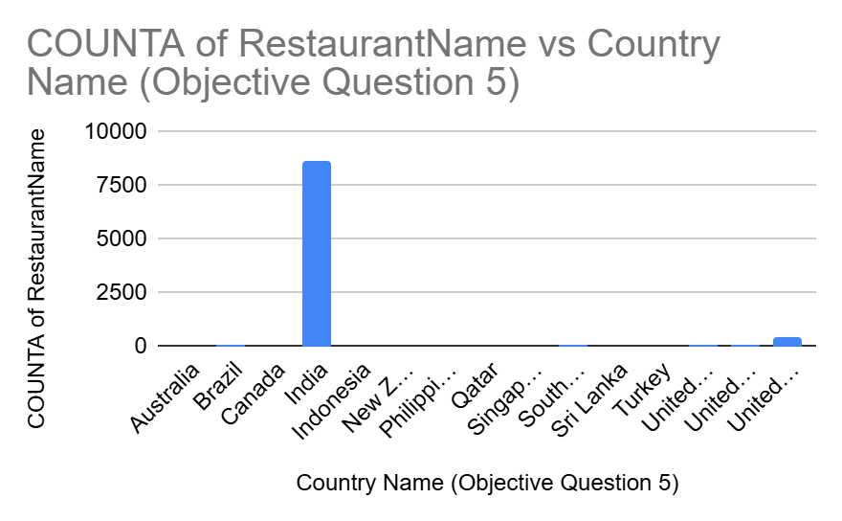
Insights:
India has the highest number of listed restaurants(8,652),indicating a highly saturated and competitive market .In contrast,Canada,Qatar,Singapore,and Sri Lanka have significantly fewer restaurants listed.

Recommendations:
The team should consider opening new restaurants in Canada,Qatar,Singapore, and Sri Lanka,as thesemarkets show considerably lower competition,giving new restaurants a better chance to establish a strong presence.

Question 2: Come up with the names of States and cities in the suggested countries suitable for opening restaurants.

Solution:

Approach:
Used a pivot Table with Country Name and City to identify the cities present in each of the suggested low-competition countries.
Charts & Tables:

Canada | Chatham-Kent | 1
 | Consort | 1
 | Vineland Station | 1
 | Yorkton | 1
Canada Total |  | 4
Qatar | Doha | 20
Qatar Total |  | 20
Singapore | Singapore | 20
Singapore Total |  | 20
Sri Lanka | Colombo | 20
Sri Lanka Total |  | 20

Insights:
Canada has 4 cities available :Chatham-Kent,Consort,Vineland,and Yorkton.qatar’s restaurants are located in Doha.Singapore itself is listed as a single city.Sri Lanka’s restaurants are located in colombo
Recommendations:
The team should consider opening new restaurants in chatham-kent,consort,vineland station,and yorkton ,doha.

Question 3: According to the countries you suggested, what is the current quality regarding ratings for restaurants that are open there?

Solution:

Approach:
Used a Pivot Table with Country Name in rows and Average Rating in Values.
Charts & Tables:
so here using pivot table to see what is the current quality regarding ratings for restaurants that is(filtered to canada,qatar,singapore,sri lanka)Country Name (Objective Question 5) AVERAGE of Rating
Canada 3.575
Qatar 4.06
Singapore 3.575
Sri Lanka 3.87 ,so overall restaurants in these low competition countries maintain a good to very good quality.

Insights:
The average ratings are:canada-3.575,qatar–4.06,Singapore-3.575,and sri lanka-3.87.
Recommendations:
Since qatar shows the highest existing rating,it may already have strong customer expectation,so new entrants should focus on match or exceeding this standard.

Question 4: Also, what is the current expenditure on food in the suggested countries, so we can keep our financial expenditure in control?

Solution:

Approach:
Used a Pivot Table with Country Name and Average Cost for Two to analyze current food expenditure in the suggested countries.
Charts & Tables:
So here using pivot table to analyse the current expenditure on food in these Countries-
Canada 36.25
Qatar 223.75
Singapore 155.75
Sri Lanka 2375,and each country uses a different currency so the result is based on the currency used.

Insights:
Canada-36.25,Qatar-223.75,Singapore-155.75,Sri Lanka-2375.
Recommendations:
Canada offers the most affordable dining,making it ideal for budget-conscious expansion,while Sri Lanka position as a premium market.financial planning should for currency differences when setting pricing strategy in each country.

Question 5: Come up with the names of restaurants from the recommended states that are our biggest competitors and also those that are rated in the lower brackets, i.e. 1-2 or 2-3.

Solution:

Approach:
Sorted restaurants under each suggested country by Average Rating.
Charts & Tables:
Queen's Cafe 2.5
Chinese Dragon Cafe 3.4
Malay Restaurant 3.5
The Paddington 3.6
CIOCONAT Lounge 3.7
Cafe Shaze 3.8
T.G.I. Friday's 4
The Commons 4
The Manhattan FISH MARKET 4
Upali's 4
Burger's King 4.1
Cafe Beverly 4.1
Carnival Ice Cream 4.1
Arabian Knights 4.2
Butter Boutique 4.2
Cricket Club Cafe 4.2
The Sizzle 4.2
Simply Strawberries By Jagro 4.5
Ministry of Crab 4.9
Sri Lanka Total 3.87
Singapore Makansutra Gluttons Bay 3
Potato Head Folk 3.1
The Lokal 3.1
Artichoke Cafe 3.2
Boufe Boutique Cafe 3.2
I Am 3.2
Super Loco 3.2
The Refinery Singapore 3.2
Sky On 57 3.4
Chye Seng Huat Hardware 3.7
Artistry 3.8
Colony 3.8
Jaan 3.8
Restaurant Andre 3.8
Bitters & Love 3.9
Rhubarb Le Restaurant 3.9
Summer Pavilion 3.9
Cut By Wolfgang Puck 4
Fratini La Trattoria 4.1
Al'frank Cookies 4.2
Singapore Total 3.575
Qatar 7st by Mumbai Spices 3.4
Indian Coffee House 3.4
Ponderosa 3.6
Coral - InterContinental Doha 3.7
Aalishan 3.8
Applebee's 3.8
Punjab Restaurant 3.8
Eatopia 3.9
Roti & Boti 3.9
MRA Bakery Sweets & Restaurant 4
Texas Roadhouse 4
The Manhattan FISH MARKET 4
Zaoq 4.2
Gokul Gujarati Restaurant 4.3
Sabai Thai - The Westin Doha Hotel & Spa 4.3
Vine - The St. Regis 4.4
Paper Moon 4.5
Zaffran Dining Experience 4.6
Gymkhana 4.7
Mainland China Restaurant 4.9
Qatar Total 4.06
Canada Consort Restaurant 3
Arigato Sushi 3.3
Tokyo Sushi 3.7
Lake House Restaurant 4.3
Canada Total 3.575e

Insights:
Canada:Biggest Competitor-Lake House Restaurant(4.3); Lower Rated-Consort Restaurant(3.0).qatar: Biggest Competitor-Mainland China Restaurant(4.9); no restaurant in 1-3 range .Singapore:Lowest Rated-Makansutra Glutton Bay (3.0).Sri Lnaka : Biggest Competitor- Ministry of Crab(4.9)::Lower rated - elite indian Restaurant(2.4),queen;s cafe (2.5).
Recommendations:
New restaurants should study the offerings of top competitors (Lake House Restaurant ,mainland china restaurant,ministry of crab .

Question 6: Which cuisines should we focus on in the newer restaurants to get better feedback? Does the choice of cuisines affect the restaurant ratings?

Solution:

Approach:
Average rating calculated cuisine-wise using pivot table.
Charts & Tables:
By creating a pivot table with cuisines grouped by average rating the analysis show that Western, Fusion, Fast Food 3.2
Thai 4.3
Steak, American 4
Steak 3.6
Sri Lankan 4
Singaporean, Chinese, Seafood, Malay, Indian 3
Singaporean, Australian, German 3.1
Seafood, Italian 4
Seafood, American 4
Seafood 4.9
Pakistani 4
North Indian, Chinese, Turkish 3.8
North Indian, Chinese, Sri Lankan 2.4
Middle Eastern, Arabian 4.2
Malaysian, North Indian, Sri Lankan 3.5
Kerala, Indian, Chinese, Bakery 4
Juices, Desserts 4.5
Japanese, Sushi 3.7
Italian, Mediterranean, Pizza 4.3
Italian, French, Bakery, Cafe 3.2
Italian, Cafe, Desserts 3.7
Italian 4.3
International 4.05
Indian, Street Food 3.4
Indian 4.18
French, Mediterranean, European 3.8
French 3.85
Finger Food 3.9
Fast Food 4.1
European, Arabian, Japanese, Bakery, Desserts 3.9
Desserts, Ice Cream 4.1
Desserts, Bakery 4.2
Continental, American, Seafood 4.2
Continental, American 4.1
Chinese, Seafood, Cantonese, Dim Sum 3.9
Chinese, Continental, Singaporean 3.4
Chinese, Canadian 3
Chinese 4.15
Cafe, Sri Lankan, Continental, American 4
Cafe, Spanish, Turkish, Greek 3.2
Cafe, Italian 3.6
Cafe, Fast Food, Beverages 3.8
Cafe 3.7
Bakery 4.2
Asian, Continental, Seafood 3.8
Asian 3.3
American, Tex-Mex 3.8
American, Steak 4
American, Mexican 3.2
American, Japanese, Singaporean 3.2
American, Fast Food, Steak, Beverages 4.2
American, Chinese, North Indian 2.5
American, Bakery, European, Burger, Fusion 3.8
American 3.1

Insights:
Seafood(4.9),Desserts(4.5),and Italian-Mediterranean(4.3),cuisines get the highest ratings.Generic North Indian-Chinese combos score lowest(2.4-3.8). Yes cuisines choice clearly affects ratings.
Recommendations:
Focus new restaurants on specialty cuisines like seafood,desserts,and italian-mediterranean instead of generic multi-cuisine menus ,since focused cuisines get better ratings.

Question 7: According to our current data, should we go for online delivery and table booking? Does that affect the customer’s ratings?

Solution:

Approach:
Compared average ratings for restaurants with vs without online delivery and table booking.
Charts & Tables:
Canada 3 1 4
Qatar 1 5 14 20
Singapore 1 5 14 20
Sri Lanka 6 11 3 20.

Insights:
Restaurants with online delivery have higher average rating (3.29 vs 2.75 without). Restaurants with table booking also have higher rating(3.48 vs 2.81 without).
Recommendations:
Yes we should go for both online delivery and table booking.

Question 8: Should the team keep the rate of cuisines higher? Will that affect the feedback? According to our data are the rates of cuisines and ratings, correlated?

Solution:

Approach:
Compared average cost for two with average rating across restaurants/countries to check correlation.
Charts & Tables:

Cuisines | AVERAGE of Rating
Western, Fusion, Fast Food | 3.2
Thai | 4.3
Steak, American | 4
Steak | 3.6
Sri Lankan | 4
Singaporean, Chinese, Seafood, Malay, Indian | 3
Singaporean, Australian, German | 3.1
Seafood, Italian | 4
Seafood, American | 4
Seafood | 4.9
Pakistani | 4
North Indian, Chinese, Turkish | 3.8
North Indian, Chinese, Sri Lankan | 2.4
Middle Eastern, Arabian | 4.2
Malaysian, North Indian, Sri Lankan | 3.5
Kerala, Indian, Chinese, Bakery | 4
Juices, Desserts | 4.5
Japanese, Sushi | 3.7
Italian, Mediterranean, Pizza | 4.3
Italian, French, Bakery, Cafe | 3.2
Italian, Cafe, Desserts | 3.7
Italian | 4.3
International | 4.05
Indian, Street Food | 3.4
Indian | 4.18
French, Mediterranean, European | 3.8
French | 3.85
Finger Food | 3.9
Fast Food | 4.1
European, Arabian, Japanese, Bakery, Desserts | 3.9
Desserts, Ice Cream | 4.1
Desserts, Bakery | 4.2
Continental, American, Seafood | 4.2
Continental, American | 4.1
Chinese, Seafood, Cantonese, Dim Sum | 3.9
Chinese, Continental, Singaporean | 3.4
Chinese, Canadian | 3
Chinese | 4.15
Cafe, Sri Lankan, Continental, American | 4
Cafe, Spanish, Turkish, Greek | 3.2
Cafe, Italian | 3.6
Cafe, Fast Food, Beverages | 3.8
Cafe | 3.7
Bakery | 4.2
Asian, Continental, Seafood | 3.8
Asian | 3.3
American, Tex-Mex | 3.8
American, Steak | 4
American, Mexican | 3.2
American, Japanese, Singaporean | 3.2
American, Fast Food, Steak, Beverages | 4.2
American, Chinese, North Indian | 2.5
American, Bakery, European, Burger, Fusion | 3.8
American | 3.1
Grand Total | 3.81875

Insights:
Higher -priced restaurants don’t have proportionally higher ratings.
Recommendations:
Don’t rely only on keeping prices high-focus on cuisine quality and service instead since these show a clear link to better ratings than piece alone.

Question 9: What is the distribution of the number of restaurants of different price ranges in all the countries?

Solution:

Approach:
Grouped restaurants by country and price range using pivot table
Charts & Tables:
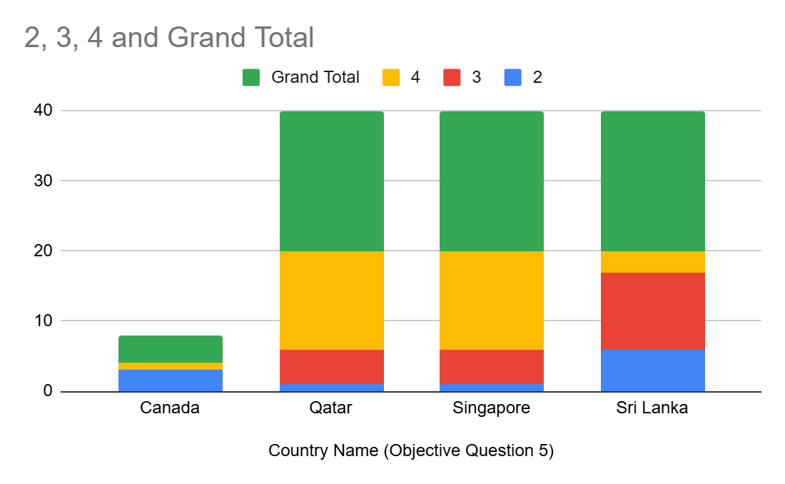

Insights:
Qatar and Singapore have the most restaurants (20 each),mostly in price ranges 3-4.Sri Lanka has 20 restaurants spread more evenly across ranges 2-4.canada has the fewest(4 restaurants),mostly in lower price ranges.
Recommendations:
Canada have fewest 4 restaurants.

Question 10: Explain your approach in brief for suggesting countries/cities in order to open new restaurants, if the objective and subjective questions would have not been given to assist you. [you have to give bullet pointers in order to answer this question]

Solution:

Approach:
>Analyze existing restaurant density per country /city to identify saturated vs underserved markets
>Study average ratings by location to find markets where customer satisfaction is already high
>check price ranges across cities to understand what pricing strategy works best where.
>identify top-perfomance cuisines and check their availability gap in each city.
Evaluate presence of table booking and online delivery ,since these correlate with higher ratings.
Study averages cost for two to gauge affordability and target customer segment per city.
>Shortlist cities with high engagement high ratings and low restaurant saturation as best expansion opportunities.
Charts & Tables:
- Table / Chart Name:
<Name of the table or chart used (should align with Excel subsheet names) along with the screenshot of chart or table>
- Description:
<What the table or chart represents>

Insights:
<Key observations derived from the data>

Recommendations:
<Actionable recommendations based on the insights>

